Q1 Write a menu-based program to take the input from the user
to print the following: Even numbers 1 to 10 , Prime numbers 1 to
10 and Factorial of a number.
#include <stdio.h>
int main() {
int choice, i, num, n, fact = 1, flag;
printf("MENU\n");
printf("1. Even numbers from 1 to 10\n");
printf("2. Prime numbers from 1 to 10\n");
printf("3. Factorial of a number\n");
printf("Enter your choice: ");
scanf("%d", &choice);
if (choice == 1) {
for (i = 1; i <= 10; i++) {
if (i % 2 == 0) {
printf("%d ", i);
}
}
}
else if (choice == 2) {
for (num = 2; num <= 10; num++) {
flag = 1;
for (i = 2; i < num; i++) {
if (num % i == 0) {
flag = 0;
break;
}
}
if (flag == 1) {
printf("%d ", num);
}
}
}
else if (choice == 3) {

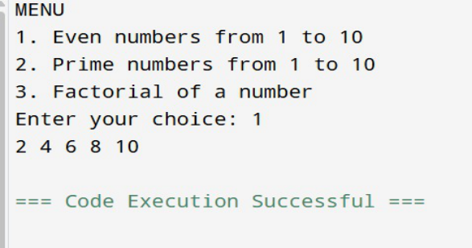
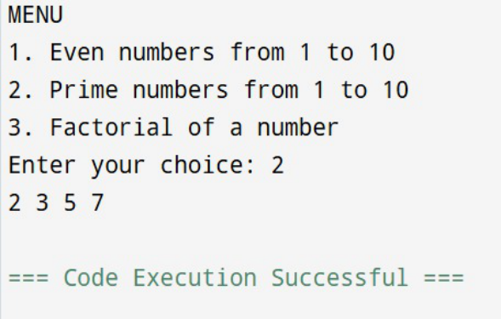

printf("Enter number: ");
scanf("%d", &n);
for (i = 1; i <= n; i++) {
fact = fact * i;
}
printf("Factorial is: %d", fact);
}
else {
printf("Invalid choice");
}
return 0;
}
Output:

Q2Write a menu-based program to take the input from the user
and print the following:Reverse of a number , Whether the
number is Armstrong or not and Whether the year is leap or not.
#include <stdio.h>
int main() {
int choice;
printf("MENU\n");
printf("1. Reverse of a number\n");
printf("2. Armstrong number\n");
printf("3. Leap year\n");
printf("Enter your choice: ");
scanf("%d", &choice);
if (choice == 1) {
int num, rev = 0;
printf("Enter number: ");
scanf("%d", &num);
while (num > 0) {
rev = rev * 10 + num % 10;
num = num / 10;
}
printf("Reverse is: %d", rev);

}
else if (choice == 2) {
int num, temp, d, s = 0;
printf("Enter number: ");
scanf("%d", &num);
temp = num;
while (temp > 0) {
d = temp % 10;
s = s + d * d * d; // For 3-digit Armstrong
temp = temp / 10;
}
if (s == num)
printf("Armstrong number");
else
printf("Not an Armstrong number");
}
else if (choice == 3) {
int year;
printf("Enter year: ");
scanf("%d", &year);
if ((year % 400 == 0) || (year % 4 == 0 && year % 100 != 0))
printf("Leap year");

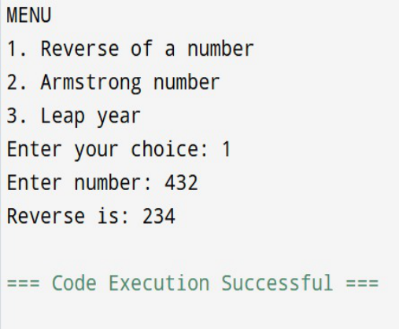

else
printf("Not a leap year");
}
else {
printf("Invalid choice");
}
return 0;
}
Output:

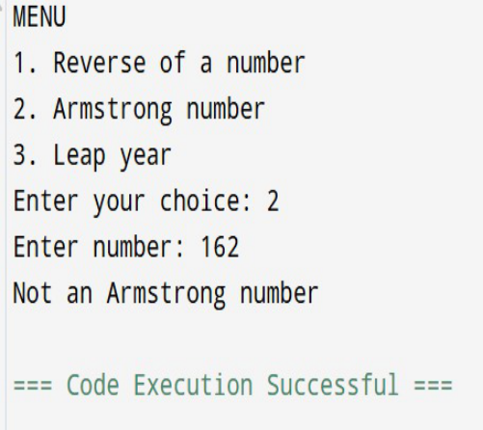

Q3 A program to perform insertion, deletion, and printing in an
array.
#include <stdio.h>
int main() {
int arr[100], n = 0;
int choice, x, i, pos, found;
printf("1. Insert\n");
printf("2. Delete\n");
printf("3. Print\n");
printf("Enter choice: ");
scanf("%d", &choice);
if (choice == 1) {
printf("Enter element: ");
scanf("%d", &x);
arr[n] = x;
n++;
printf("Array: ");
for (i = 0; i < n; i++)
printf("%d ", arr[i]);

}
else if (choice == 2) {
printf("Enter element to delete: ");
scanf("%d", &x);
found = 0;
for (i = 0; i < n; i++) {
if (arr[i] == x) {
pos = i;
found = 1;
break;
}
}
if (found == 1) {
for (i = pos; i < n - 1; i++)
arr[i] = arr[i + 1];
n--;
} else {
printf("Element not found\n");
}
printf("Array: ");
for (i = 0; i < n; i++)
printf("%d ", arr[i]);
}
else if (choice == 3) {
printf("Array: ");
for (i = 0; i < n; i++)
printf("%d ", arr[i]);
}
else {
printf("Invalid choice");
}
return 0;

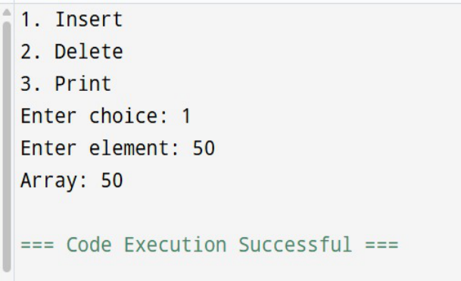

}
Output:
Q4 Write a program to find the arithmetic operations on
matrices:
Sum and Subtraction, Product of 2 matrices , Transpose of a
matrix.
#include <stdio.h>
int main() {
int A[2][2] = {{1,2},{3,4}};
int B[2][2] = {{5,6},{7,8}};
int C[2][2];
int i, j, k;
// Addition
printf("Addition:\n");
for(i=0;i<2;i++){
for(j=0;j<2;j++){
printf("%d ", A[i][j] + B[i][j]);
}
printf("\n");
}
// Subtraction
printf("Subtraction:\n");

for(i=0;i<2;i++){
for(j=0;j<2;j++){
printf("%d ", A[i][j] - B[i][j]);
}
printf("\n");
}
// Proper Matrix Multiplication
printf("Multiplication:\n");
for(i=0;i<2;i++){
for(j=0;j<2;j++){
C[i][j] = 0;
for(k=0;k<2;k++){
C[i][j] += A[i][k] * B[k][j];
}
printf("%d ", C[i][j]);
}
printf("\n");
}
// Transpose of A
printf("Transpose of Matrix A:\n");
for(i=0;i<2;i++){
for(j=0;j<2;j++){
printf("%d ", A[j][i]);
}
printf("\n");
}
return 0;
}
Output:

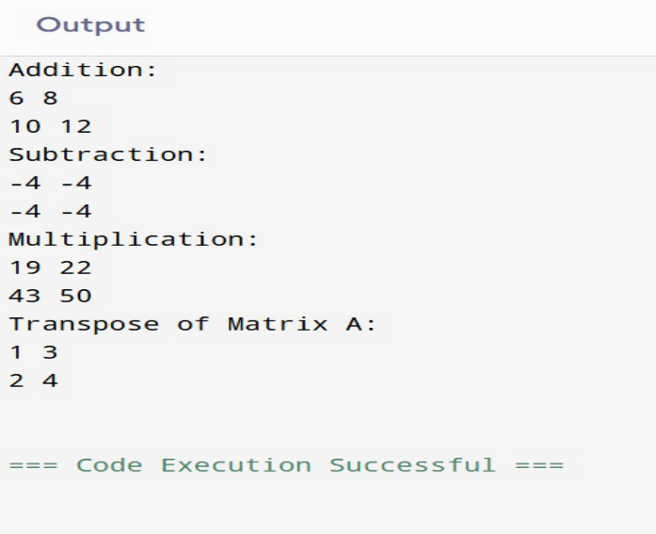

Q5 Find the element in array by using linear search.
#include <stdio.h>
int main() {
int a[5], find, i, flag = 0;
for(i = 0; i < 5; i++){
printf("Enter at %d : ", i+1);
scanf("%d", &a[i]);
}
printf("You want to find: ");
scanf("%d", &find);
for(i = 0; i < 5; i++){
if(a[i] == find){
printf("%d is found at position %d\n", find, i+1);
flag = 1;
break;

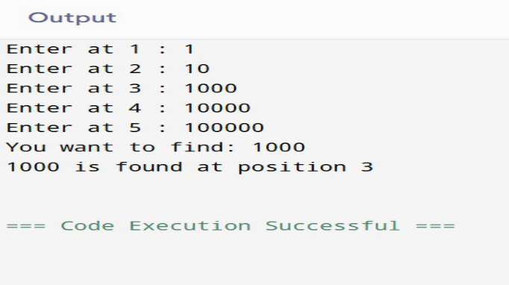

}
}
if(flag == 0){
printf("Element not found");
}
return 0;
}
Output:
Q6 Find the element in array by using binary search
#include <stdio.h>
int bs(int a[], int size, int found) {
int low = 0;
int high = size - 1;
while (low <= high) {
int mid = (low + high) / 2;
if (a[mid] == found) {

return mid;
} else if (found > a[mid]) {
low = mid + 1;
} else {
high = mid - 1;
}
}
return -1;
}
int main() {
int a[5], findbro = 0;
int size = sizeof(a) / sizeof(a[0]);
printf("Enter 5 elements in sorted order:\n");
for (int i = 0; i < size; i++) {
printf("Enter element at %d place: ", i);
scanf("%d", &a[i]);
}
printf("Which number to find: ");
scanf("%d", &findbro);
int res = bs(a, size, findbro);
if (res == -1) {
printf("Unable to find it");
} else {
printf("Found it, %d at index %d", findbro, res);
}
return 0;
}
Output:

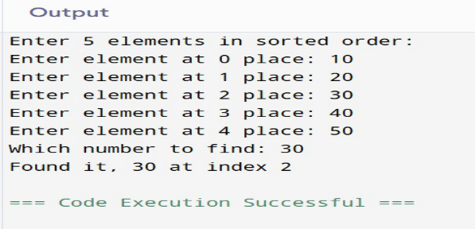

Q7 Infix to postfix
#include <stdio.h>
#include <ctype.h>
char stack[100];
int top = -1;
void push(char ch) {
stack[++top] = ch;
}
char pop() {
return stack[top--];
}
int precedence(char ch) {
if (ch == '+' || ch == '-') return 1;
if (ch == '*' || ch == '/') return 2;
return 0;
}
int main() {
char infix[100], postfix[100];
int i = 0, j = 0;
printf("Enter Infix Expression: ");
scanf("%s", infix);

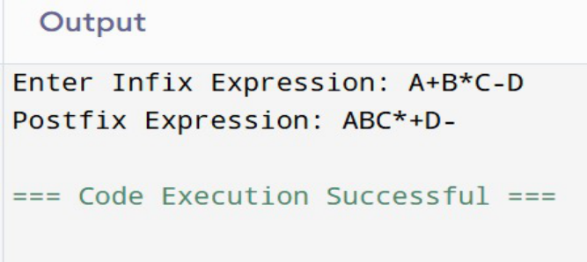

while (infix[i] != '\0') {
if (isalnum(infix[i])) {
postfix[j++] = infix[i];
}
else if (infix[i] == '(') {
push(infix[i]);
}
else if (infix[i] == ')') {
while (top != -1 && stack[top] != '(')
postfix[j++] = pop();
pop();
}
else {
while (top != -1 && precedence(stack[top]) >= precedence(infix[i]))
postfix[j++] = pop();
push(infix[i]);
}
i++;
}
while (top != -1)
postfix[j++] = pop();
postfix[j] = '\0';
printf("Postfix Expression: %s", postfix);
return 0;
}
Output:

Q8 write a program to perform all operation for the
queue using the array .
#include <stdio.h>
#include <stdlib.h>
#define MAX 5
int queue[MAX];
int front = -1;
int rear = -1;
int isFull() {
if (rear == MAX - 1)
return 1;
return 0;
}
int isEmpty() {
if (front == -1 || front > rear)
return 1;
return 0;
}
void enqueue(int value) {
if (isFull()) {
printf("Queue is Full! Cannot insert %d\n", value);
return;
}
if (front == -1)
front = 0;
rear++;
queue[rear] = value;
printf("%d inserted into queue\n", value);
}
void dequeue() {

if (isEmpty()) {
printf("Queue is Empty! Cannot delete\n");
return;
}
printf("%d deleted from queue\n", queue[front]);
front++;
}
void peek() {
if (isEmpty()) {
printf("Queue is Empty!\n");
return;
}
printf("Front element is: %d\n", queue[front]);
}
// Function to display queue
void display() {
if (isEmpty()) {
printf("Queue is Empty!\n");
return;
}
printf("Queue elements are: ");
for (int i = front; i <= rear; i++) {
printf("%d ", queue[i]);
}
printf("\n");
}
int main() {
int choice, value;
while (1) {
printf("\n--- Queue Operations ---\n");
printf("1. Enqueue\n");
printf("2. Dequeue\n");
printf("3. Peek\n");

printf("4. Display\n");
printf("5. Exit\n");
printf("Enter your choice: ");
scanf("%d", &choice);
switch (choice) {
case 1:
printf("Enter value to insert: ");
scanf("%d", &value);
enqueue(value);
break;
case 2:
dequeue();
break;
case 3:
peek();
break;
case 4:
display();
break;
case 5:
exit(0);
default:
printf("Invalid choice!\n");
}
}
return 0;
}
Output:

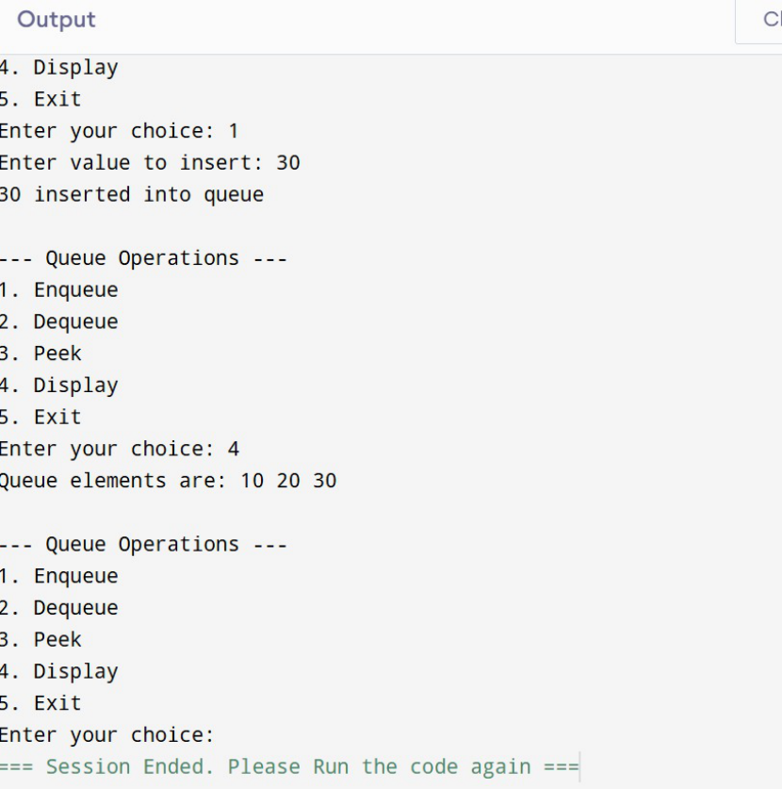

Q9 write a program to perform all operation for the
circular queue using the array.
#include <stdio.h>
#define SIZE 5
int queue [SIZE];
int front = -1, rear = -1;
void enqueue (){
int value, i, n;
printf ("total elements wants to be inserted: ");
scanf ("%d", &n);
for (i=0; i<n; i++){

if ((rear + 1) % SIZE == front) {
printf ("circular queue is overflow!\n");
return;
}
printf ("enter value: ");
scanf ("%d", &value);
if (front == -1)
front = 0;
rear = (rear + 1) % SIZE;
queue[rear] = value;
printf ("value inserted! %d\n");
}
}
void dequeue() {
if (front == -1) {
printf("Circular Queue Underflow! \n");
} else {
printf("Deleted: %d\n", queue[front]);
if (front == rear) {
front = rear = -1;
} else {
front = (front + 1) % SIZE;
}
}
}
void peek() {
if (front == -1) {
printf("Circular Queue is Empty!\n");
} else {
printf("Front element is: %d\n", queue[front]);
}
}
void display() {

int i;
if (front == -1) {
printf("Circular Queue is Empty! \n");
} else {
printf("Queue elements: ");
i = front;
while (1) {
printf("%d ", queue[i]);
if (i == rear)
break;
i = (i + 1) % SIZE;
}
printf("\n");
}
}
int main() {
int choice;
while (1) {
printf("QUEUE MENU:-\n");
printf("1.Enqueue 2.Dequeue 3.Peek 4.Display 5.Exit\n");
printf("Enter choice: ");
scanf("%d", &choice);
switch (choice) {
case 1: enqueue(); break;
case 2: dequeue(); break;
case 3: peek(); break;
case 4: display(); break;
case 5: return 0;
default: printf("Invalid choice\n");
}
}
}

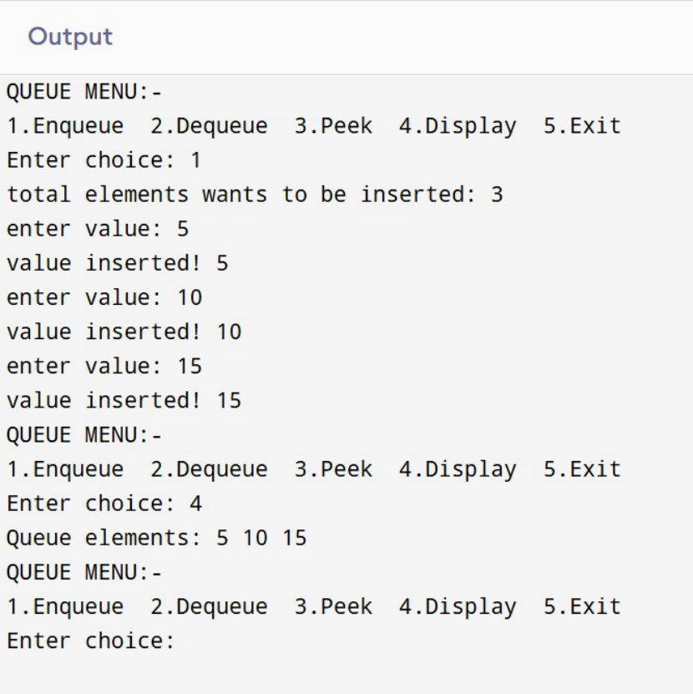

Output:

Q 10 Write a program to perform all operations for the
Stack using an Array.
#include <stdio.h>
#include <stdlib.h>
#define MAX 5
int stack[MAX];
int top = -1;
// Push operation
void push(int value) {
if (top == MAX - 1) {
printf("Stack Overflow\n");
} else {
top++;
stack[top] = value;
printf("%d pushed into stack\n", value);
}
}
void pop() {
if (top == -1) {
printf("Stack Underflow\n");
} else {
printf("%d popped from stack\n", stack[top]);
top--;
}
}
void peek() {
if (top == -1) {
printf("Stack is empty\n");
} else {
printf("Top element is %d\n", stack[top]);
}
}
void display() {
if (top == -1) {
printf("Stack is empty\n");

} else {
printf("Stack elements are:\n");
for (int i = top; i >= 0; i--) {
printf("%d\n", stack[i]);
}
}
}
int main() {
int choice, value;
while (1) {
printf("\n--- Stack Operations ---\n");
printf("1. Push\n2. Pop\n3. Peek\n4. Display\n5. Exit\n");
printf("Enter your choice: ");
scanf("%d", &choice);
switch (choice) {
case 1:
printf("Enter value to push: ");
scanf("%d", &value);
push(value);
break;
case 2:
pop();
break;
case 3:
peek();
break;
case 4:
display();
break;
case 5:
exit(0);
default:

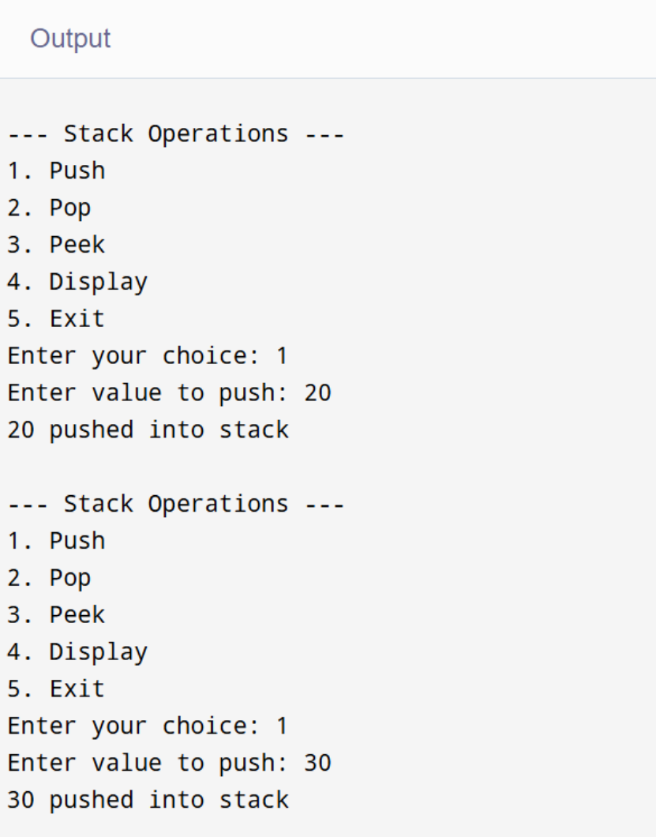

printf("Invalid choice\n");
}
}
return 0;
}

Q11 Write a program to evaluate the Postfix Notation.
#include <stdio.h>
#include <ctype.h>
#define MAX 100
int stack[MAX];
int top = -1;
void push(int value) {
stack[++top] = value;
}
int pop() {
return stack[top--];
}
int evaluatePostfix(char exp[]) {
int i = 0;
int a, b;
while (exp[i] != '\0') {
if (isdigit(exp[i])) {
push(exp[i] - '0');
}
else {
b = pop();
a = pop();
switch (exp[i]) {
case '+': push(a + b); break;
case '-': push(a - b); break;
case '*': push(a * b); break;
case '/': push(a / b); break;

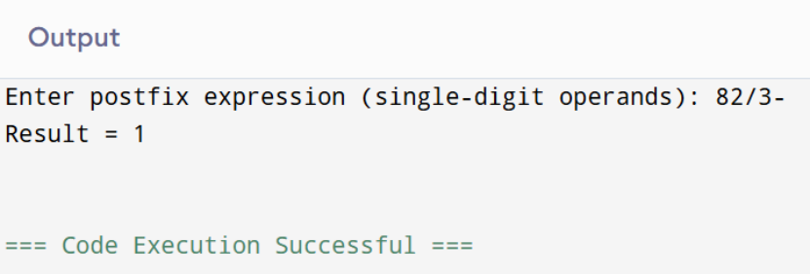

}
}
i++;
}
return pop();
}
int main() {
char exp[MAX];
printf("Enter postfix expression (single-digit operands): ");
scanf("%s", exp);
int result = evaluatePostfix(exp);
printf("Result = %d\n", result);
return 0;
}
Q12 Write a program to perform the operations of the
linked list: - Insertion, - Deletion, -Display
#include <stdio.h>
#include <stdlib.h>
struct Node {
int data;
struct Node* next;
};

struct Node* head = NULL;
void insert(int value) {
struct Node* newNode = (struct Node*)malloc(sizeof(struct Node));
newNode->data = value;
newNode->next = head;
head = newNode;
printf("%d inserted\n", value);
}
void delete(int value) {
struct Node *temp = head, *prev = NULL;
if (temp != NULL && temp->data == value) {
head = temp->next;
free(temp);
printf("%d deleted\n", value);
return;
}
while (temp != NULL && temp->data != value) {
prev = temp;
temp = temp->next;
}
if (temp == NULL) {
printf("Value not found\n");
return;
}
prev->next = temp->next;
free(temp);
printf("%d deleted\n", value);
}
void display() {

struct Node* temp = head;
if (temp == NULL) {
printf("List is empty\n");
return;
}
printf("Linked List: ");
while (temp != NULL) {
printf("%d -> ", temp->data);
temp = temp->next;
}
printf("NULL\n");
}
int main() {
int choice, value;
while (1) {
printf("\n--- Linked List Operations ---\n");
printf("1. Insert\n2. Delete\n3. Display\n4. Exit\n");
printf("Enter your choice: ");
scanf("%d", &choice);
switch (choice) {
case 1:
printf("Enter value to insert: ");
scanf("%d", &value);
insert(value);
break;
case 2:
printf("Enter value to delete: ");
scanf("%d", &value);
delete(value);
break;
case 3:
display();

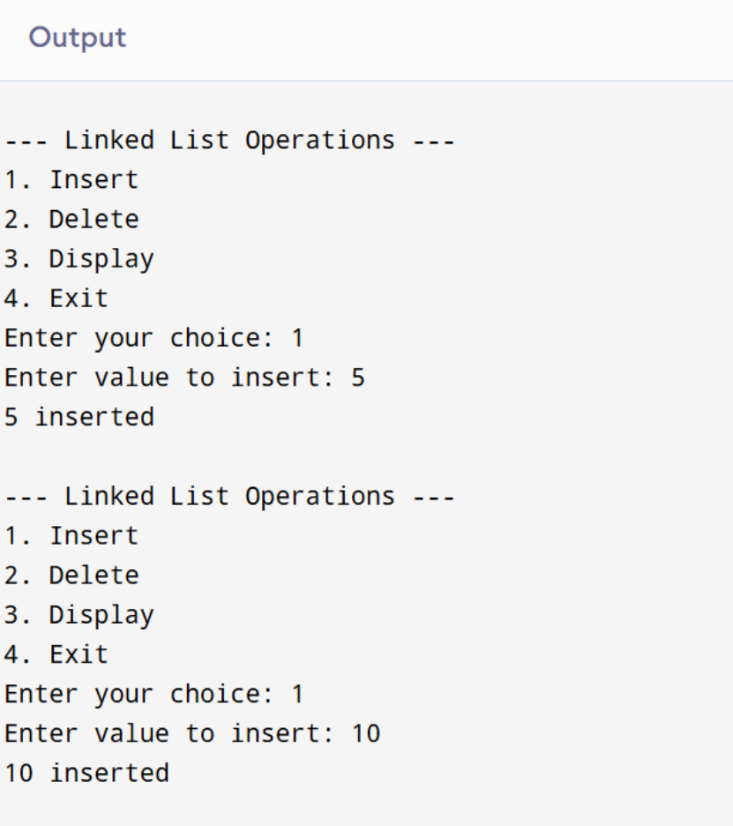

break;
case 4:
exit(0);
default:
printf("Invalid choice\n");
}
}
return 0;
}

Q13Write a program to perform the operations of the
Circular linked list: - Insertion, - Deletion, -Display
#include <stdio.h>
#include <stdlib.h>
struct Node {
int data;
struct Node* next;
};
struct Node* last = NULL;
void insert(int value) {
struct Node* newNode = (struct Node*)malloc(sizeof(struct Node));
newNode->data = value;
if (last == NULL) {
last = newNode;
newNode->next = newNode;
} else {
newNode->next = last->next;
last->next = newNode;
}
printf("%d inserted\n", value);
}
void delete(int value) {
if (last == NULL) {
printf("List is empty\n");
return;
}
struct Node *temp = last->next, *prev = last;

if (last->data == value && last->next == last) {
free(last);
last = NULL;
printf("%d deleted\n", value);
return;
}
if (temp->data == value) {
last->next = temp->next;
free(temp);
printf("%d deleted\n", value);
return;
}
prev = temp;
temp = temp->next;
while (temp != last->next) {
if (temp->data == value) {
prev->next = temp->next;
if (temp == last)
last = prev;
free(temp);
printf("%d deleted\n", value);
return;
}
prev = temp;
temp = temp->next;
}
printf("Value not found\n");
}
void display() {
if (last == NULL) {

printf("List is empty\n");
return;
}
struct Node* temp = last->next;
printf("Circular Linked List: ");
do {
printf("%d -> ", temp->data);
temp = temp->next;
} while (temp != last->next);
printf("(back to start)\n");
}
int main() {
int choice, value;
while (1) {
printf("\n--- Circular Linked List ---\n");
printf("1. Insert\n2. Delete\n3. Display\n4. Exit\n");
printf("Enter choice: ");
scanf("%d", &choice);
switch (choice) {
case 1:
printf("Enter value: ");
scanf("%d", &value);
insert(value);
break;
case 2:
printf("Enter value to delete: ");
scanf("%d", &value);
delete(value);
break;
case 3:
display();

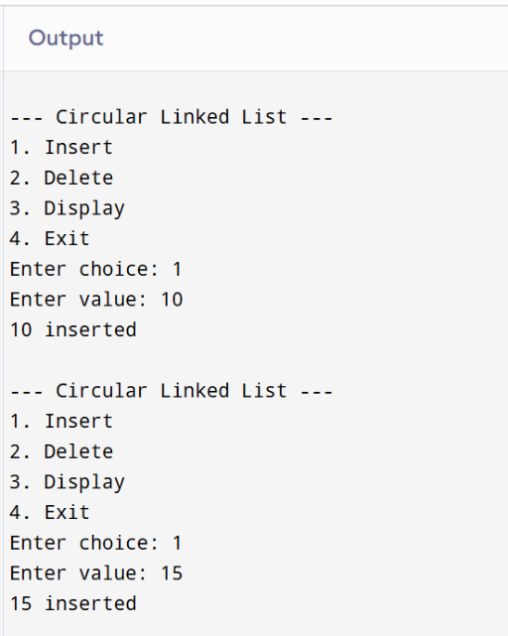

break;
case 4:
exit(0);
default:
printf("Invalid choice\n");
}
}
return 0;
}
Q14 Write a program to perform all operations for
Circular Queue using Linked List
#include <stdio.h>
#include <stdlib.h>
struct Node {
int data;

struct Node* next;
};
struct Node *front = NULL, *rear = NULL;
void enqueue(int value) {
struct Node* newNode = (struct Node*)malloc(sizeof(struct Node));
newNode->data = value;
if (rear == NULL) {
front = rear = newNode;
rear->next = front;
} else {
rear->next = newNode;
rear = newNode;
rear->next = front;
}
printf("%d inserted\n", value);
}
void dequeue() {
if (front == NULL) {
printf("Queue Underflow\n");
return;
}
struct Node* temp = front;
if (front == rear) {
printf("%d deleted\n", front->data);
front = rear = NULL;
} else {
printf("%d deleted\n", front->data);
front = front->next;
rear->next = front;
}

free(temp);
}
void display() {
if (front == NULL) {
printf("Queue is empty\n");
return;
}
struct Node* temp = front;
printf("Circular Queue: ");
do {
printf("%d -> ", temp->data);
temp = temp->next;
} while (temp != front);
printf("(front)\n");
}
int main() {
int choice, value;
while (1) {
printf("\n--- Circular Queue (Linked List) ---\n");
printf("1. Enqueue\n2. Dequeue\n3. Display\n4. Exit\n");
printf("Enter your choice: ");
scanf("%d", &choice);
switch (choice) {
case 1:
printf("Enter value: ");
scanf("%d", &value);
enqueue(value);
break;
case 2:

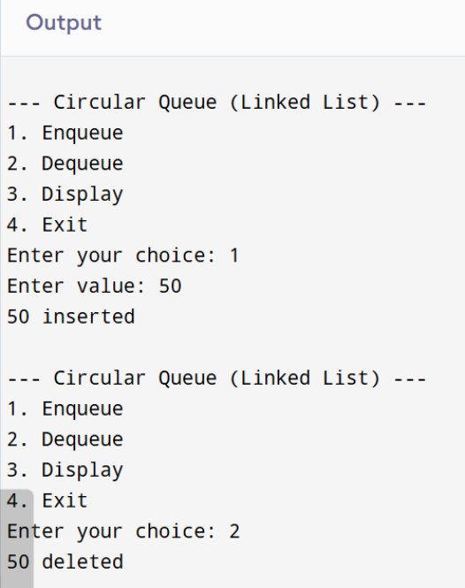

dequeue();
break;
case 3:
display();
break;
case 4:
exit(0);
default:
printf("Invalid choice\n");
}
}
return 0;
}

Q 15 Write a program to perform the operations of the

Double linked list: - Insertion, - Deletion, -Display
#include <stdio.h>
#include <stdlib.h>
struct Node {
int data;
struct Node* next;
};
struct Node *front = NULL, *rear = NULL;
void enqueue(int value) {
struct Node* newNode = (struct Node*)malloc(sizeof(struct Node));
newNode->data = value;
if (rear == NULL) {
front = rear = newNode;
rear->next = front;
} else {
rear->next = newNode;
rear = newNode;
rear->next = front;
}
printf("%d inserted\n", value);
}
void dequeue() {
if (front == NULL) {
printf("Queue Underflow\n");
return;
}
struct Node* temp = front;

if (front == rear) {
printf("%d deleted\n", front->data);
front = rear = NULL;
} else {
printf("%d deleted\n", front->data);
front = front->next;
rear->next = front;
}
free(temp);
}
void display() {
if (front == NULL) {
printf("Queue is empty\n");
return;
}
struct Node* temp = front;
printf("Circular Queue: ");
do {
printf("%d -> ", temp->data);
temp = temp->next;
} while (temp != front);
printf("(front)\n");
}
int main() {
int choice, value;
while (1) {
printf("\n--- Circular Queue (Linked List) ---\n");
printf("1. Enqueue\n2. Dequeue\n3. Display\n4. Exit\n");
printf("Enter your choice: ");
scanf("%d", &choice);

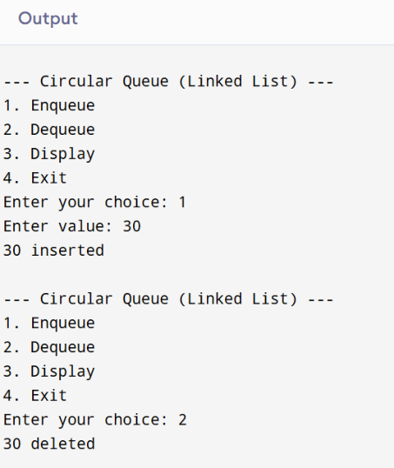

switch (choice) {
case 1:
printf("Enter value: ");
scanf("%d", &value);
enqueue(value);
break;
case 2:
dequeue();
break;
case 3:
display();
break;
case 4:
exit(0);
default:
printf("Invalid choice\n");
}
}
return 0;
}

Q 16 Write a program to perform all operations for the
Stack using Linked List
#include <stdio.h>
#include <stdlib.h>
struct node {
int data;
struct node *next;
};
struct node *top = NULL;
void push(int value) {
struct node *newNode = (struct node*)malloc(sizeof(struct node));
newNode->data = value;
newNode->next = top;
top = newNode;
}
void pop() {
if(top == NULL) {
printf("Stack Underflow\n");
return;
}
struct node *temp = top;
printf("Deleted element: %d\n", top->data);
top = top->next;
free(temp);
}
void display() {
struct node *temp = top;
if(temp == NULL) {
printf("Stack is empty\n");
return;
}
printf("Stack elements:\n");
while(temp != NULL) {

printf("%d\n", temp->data);
temp = temp->next;
}
}
int main() {
int choice, value;
while(1) {
printf("\n1.Push\n2.Pop\n3.Display\n4.Exit\n");
printf("Enter choice: ");
scanf("%d",&choice);
switch(choice) {
case 1:
printf("Enter value: ");
scanf("%d",&value);
push(value);
break;
case 2:
pop();
break;
case 3:
display();
break;
case 4:
exit(0);
default:
printf("Invalid choice\n");
}
}
}

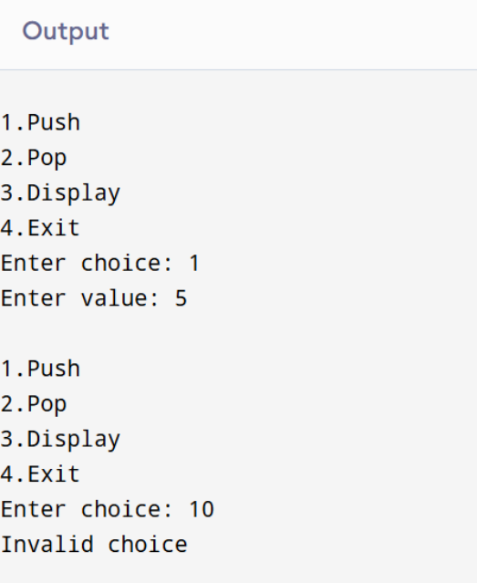

Q17 Write a program to perform all operations for the
Queue using Linked List
#include <stdio.h>
#include <stdlib.h>
struct node {
int data;
struct node *next;
};
struct node *front = NULL;
struct node *rear = NULL;
void enqueue(int value) {
struct node *newNode = (struct node*)malloc(sizeof(struct node));
newNode->data = value;
newNode->next = NULL;
if(rear == NULL) {
front = rear = newNode;

}
else {
rear->next = newNode;
rear = newNode;
}
}
void dequeue() {
if(front == NULL) {
printf("Queue Underflow\n");
return;
}
struct node *temp = front;
printf("Deleted element: %d\n", front->data);
front = front->next;
if(front == NULL)
rear = NULL;
free(temp);
}
void display() {
struct node *temp = front;
if(temp == NULL) {
printf("Queue is empty\n");
return;
}
printf("Queue elements:\n");
while(temp != NULL) {
printf("%d ", temp->data);
temp = temp->next;
}
printf("\n");
}
int main() {

int choice, value;
while(1) {
printf("\n1.Enqueue\n2.Dequeue\n3.Display\n4.Exit\n");
printf("Enter choice: ");
scanf("%d",&choice);
switch(choice) {
case 1:
printf("Enter value: ");
scanf("%d",&value);
enqueue(value);
break;
case 2:
dequeue();
break;
case 3:
display();
break;
case 4:
exit(0);
default:
printf("Invalid choice\n");
}
}
}

